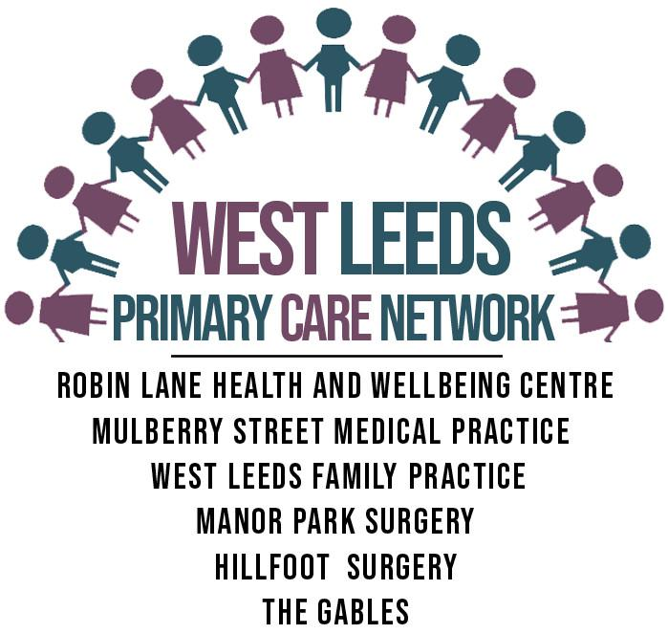
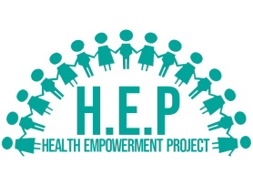
Health Empowerment Project (HEP)
Community Groups & Activities
HEP is a charity founded by West Leeds Primary Care Network (WLPCN). HEP facilitates community groups and activities, promoting the health & wellbeing of WLPCN patients. All groups are run by Volunteers and are overseen by the WLPCN’s Community Wellbeing Team.

Day | Group Name | Time + Location | Details
Monday
Tuesday | Pudsey Chit Chat Group  Calverley Chit Chat Group  Henry Programme  (HENRY - Healthy Exercise & Nutrition for the Really Young) | 2nd Tuesday of the month  10.30am to 12.30pm @  St James the Great Church, Pudsey, LS28 8RA.  3rd Tuesday of the month 10am to 12pm @  Calverley Methodist Church, LS28 5PS.  Commencing 20th April @ 10am – 12pm @ Pudsey Wellbeing Charity, Robin Lane, Pudsey, LS28 7BR  Dates: 20th & 27th of April,  4th, 11th, 18th & 25th of May  8th & 15th of June. | Come and enjoy a chat, board games, a hot drink and cake. Seated exercise session also included.  As above.  A free 8-week programme for parents & carers of primary school aged children. The programme aims to help parents and carers develop a healthier, happier lifestyle that the whole family can enjoy.
Wednesday
Thursday | Diabetes Peer Support Group  Men’s Group  Educational Support Group for people with a diagnosis of Cancer | 1st Thursday of the month 2pm - 3.30pm @  Pudsey House, LS28 7BE.  2nd Thursday of every month 1.30pm - 3.30pm @  Pudsey House, LS28 7BE.  1st & 3rd Thursday of every month starting on 23rd March 1pm - 3pm @  Pudsey Wellbeing Charity, Robin Lane, Pudsey, LS28 7BR | Monthly support group to provide education and advice for those with type 2 diabetes. Guest speakers at every session. (Sessions running February till October 2023).  Safe and friendly environment for men to socialise and increase social connections within the local area.  This group aims to support people with a diagnosis of cancer and teach symptom-management strategies. A safe space for peer support and social participation.  For further information please contact Claire on:  07736 972 348 or email Claire.richardson42@nhs.net
Friday | Parent Support Group | 3rd Friday of the month 10am - 12pm @  Little People Nurseries, Stanningley, LS28 6DX. | Support group for parents of babies/toddlers (0 to 5). Safe space for play and supportive environment for parents to share experiences and feel supported.
Saturday | Young Person’s Group | 4th Saturday of the month starting 25th March 1pm - 3pm @ Bramley Baptist Church, LS13 3RD. | Peer support for young people to socialise and join in with activities promoting wellbeing.
Day not disclosed | Women’s Domestic Abuse Support Group | Monthly (location not disclosed) | A safe, supportive peer support group for women who are victims/survivors of abuse, whether this is current or historic abuse.  For further information please contact Ailsa on: - 07736 972 386 or email: ailsa.mclaughlin@nhs.net
Coming soon | Carer’s Group | Monthly (location TBC) | Peer support group for Carers to come together and socialise in a relaxed and supportive environment.

*Please note all groups are free to attend and are for patients who attend a GP Practice within WLPCN. Practices within WLPCN include: - Robin Lane Health & Wellbeing Centre, Mulberry Street Medical Practice, West Leeds Family Practice, Manor Park Surgery, Hillfoot Surgery and the Gables Surgery.
*For more information, please contact the Community Wellbeing Team via email: lwccg.wlpcncwteam@nhs.net or contact Nick on: - 07736 972 331.
*Practitioners can refer patients by sending a task to the ‘Health Empowerment Project’ user group on the WLPCN Task group, stating the name of the group they are referring to.

